Chapter 1
Why this approach and Why now? This narrative is an expansion of the first chapter in this book and is a prelude to the first chapter in the second edition of this book. The second edition of the book is likely to get in press by the end of April of 2021.

Chapter 2
This chapter provides an overview on the ‘Evolution of Concepts in Terminology’ in use to describe behavioral expressions in NCD as well the ‘models’ for the presence of BE in D/NCD. This journey began with a comprehensive review of the published literature in the field over the last three decades on the existing terminology and models put forth in understanding the presence of behaviors in D/NCD. The results revealed that literature was fraught with inconsistencies with respect to definitions of commonly used terminology, inconsistent and heterogeneous application of terminology for different sets of behaviors, in different clinical contexts in different clinical environments. Likewise, significant limitations were identified in the ‘models’ used to justify for the presence of BE in D/NCD. In fact, all published models for understanding the occurrences of behaviors in patients with D/NCD dichotomized along Biological or Psychosocial paradigms.

A Comprehensive Biopsychosocial Model for the presence of BE in D/NCD is yet to be established!
Chapter 3
Acknowledging these deficits and adhering to the basic academic definitions of Reference Terminology and Classification Systems (3), a sequential approach developed, as the way forward to address the identified deficits in the field. The first step was to posit a Biopsychosocial Model for the presence of behaviors in NCD. Literature identified multifaceted factors contributory to the occurrence of behaviors in patients with D/NCD:
- Biological Factors [stage of the disease with or without the presence of premorbid presence or absence of co-morbid mental illness (SOD), inherent Circadian Rhythms (CR) and Innate Physiological Needs (IPN)],
- Personal Factors (pre-morbid personality and acquired coping strategies), and
- Environmental Factors [Milieu Structures (MS) and Interpersonal Interactions (IPI)].
A complex interplay amongst each of these variables hypothesized to justify the generation of a comprehensive Biopsychosocial (BPS) Model and the appointment of new terminology to label behaviors in D/NCD: Stage Congruent Responsive Behaviors (SRCB) (pronounced, “scrub”). Figure 1 describes how the Biological, Personal, and Environmental Factors interact dynamically amongst each other to result in generation of behaviors. Internal Factors (CR or IPN) and External Factors (MS or IPI) are inputted into the Information Processing Module [Biological (Stage of Disease) and Personal (pre-morbid personality and acquired coping mechanism) Factors].
The internal and external factors are assimilated, proccessed and integrated into meaningful bites of information and outputted as behavioral expressions. The quality of behavioral expressions chnages with the progression of the disease and its interplay with pre-morbid personality and acquired coping mechanisms thereby resulting in coining of the term Stage Congurent Responsive Behaviors (SCRB). The emergence of the behaviors are congruent, and responsive to, the chnages in the brain functioning witht the disease advancement. Please refer to the book for details on the functionaing of the model.
Figure 1.
Functional model of Stage Congruent Responsive Behaviors
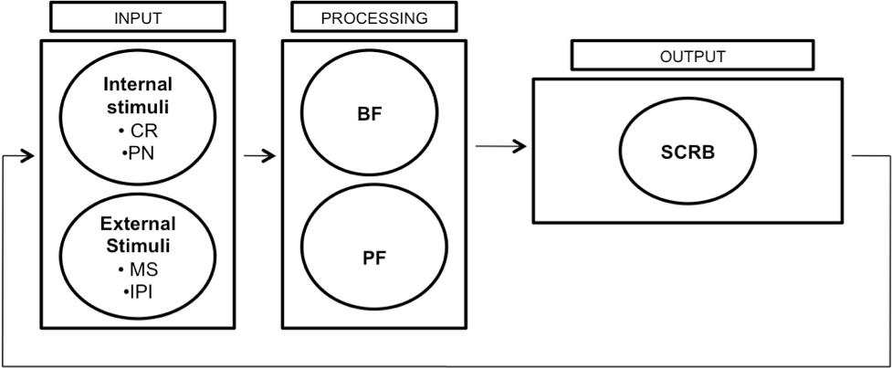

The next obvious step was to seek direction, from published literature, on identifying an approach to classify behavioral expressions. The criteria put forth by Davis, Buckwater and Burgio (1997) selected to justify the methodology to classify behavioral expressions. This criteria and format chosen due to its relevance in classifying behavioral symptoms in D/NCD and its widespread acceptability. It is commonly cited and used in research regarding behaviors in persons with dementia/NCD or related mental health disorders.
New Classification for SCRB
Davis et al. (4) proposed a set of criteria, based upon these definitions, as a way of developing a more reliable and valid measure of classification of behaviors in D/NCD. These criteria are as follows:
- Identification of the target population,
- Construction of items into categories which adequately represent the domain,
- Definition of the ‘purpose’ and ‘meaning’ of the doamin, and
- Specification of the construct of the category or domain.

Identification of target population.
Individuals with NCD who are unable to engage in a reliable and valid clinical assessment (history and mental state examination).

Construction of items into categories.
Collection of vast and heterogeneous phenotypic symptoms into a database. Manually stratifying the behavioral symptoms into ‘alike’ or similar’ categories. The chosen title of each of these ‘alike’ or similar’ categories adequately reflects the collective ‘meaning’ of the behavioral symptoms represented therein.

Definition of the purpose of the measure.
Defining the ‘purpose’ and ‘meaning’ of each established behavioral category; what is the individual with dementia communicating through their expressions. Family members and health care professionals need a framework to apply to the observed behavioral expression to interpret the reasons for their presence, in that context, the purpose it is serving the individuals with dementia. Defining ‘purpose’ and ‘meaning’ is essential to developing a fitting behavioral care plans to address the identified ‘needs’ being expressed through the behaviors.

Specification of the construct of each category.
Justification was sought from existing psychology literature to support the collection of ‘alike’ or ‘similar’ behavioral symptoms into individual behavioral categories, representing by an appropriate title, towards representation of their ‘purpose’ and ‘meaning’. To this end, extensive review of the literature in neuropsychology, behavioral psychology, general psychology and social psychology undertaken. Neuropsychology literature offered Theories on Regulation of Sensorium and Information Processing Theories, Behavioral psychology offered Motivational Theories, General psychology offered Theories on Regulation of Emotions and Social Psychology offered Theories on Principles of Compliance and Aggression.

Chapter 4
This chapter presents the first psychological construct used to justify the classification of BE into the behavioral category of Disorganized and Mis-Identification Expressions. This psychological construct is derived from neuropsychology literature, which forms the basis of understanding of the Higher Cortical Intellectual Functioning of the brain. This psychological construct involves the understanding of the cascade involved in transfer of information on the Information Processing Pathways with the formation of varied higher cortical functions. Neuropsychologists have proposed theories which govern the functioning of the information processing pathways in the formation of cognition. This chapter assists in understanding of the normal functioning of the information processing pathways, and how impairment in the functioning of these pathways with the onset of NCD, results in the manifestation of the two behavioral expressions; Disorganized and Mis-Identification.

Chapter 5
This chapter helps in the understanding of the second psychological construct used to justify the classification of the four behavioral expression of Goal-Directed, Apathy, Motor and Importuning. This psychological construct is derived from behavioral psychology literature and assists in understanding the normal structural and functional organization of the Motivational Circuitry. This circuitry is key to the identification of and satiation of ‘needs’ in the human body. Impairment in the motivational circuits, with the onset of NCD, leads to emergence of one of the four behavioral categories of Goal-Directed, Apathy, Motor and Importuning Expressions.

Chapter 6
This chapter focuses on the psychological construct used to justify the classification of three behavioral categories of Emotional, Vocal and Fretful Expressions. This psychological construct is derived from general psychology and assists us in understanding of the normal structural and functional organization of the Emotional Regulatory Circuits. Impairment in the functioning of these circuits, with the onset of NCD, results in emergence of the behavioral categories of Emotional, Vocal and Fretful-Trepidated Expressions.

Chapter 7
This chapter assists in the understanding of the justification of classification of the behavioral categories of Oppositional, Physical and Sexual Expressions. This psychological construct is derived from Social psychology and is based in psychological theories, which govern self-regulatory and monitoring circuits. Impairment in these circuits, due to the disease of dementia, will result in the manifestation of the three behavioral categories of Oppositional, Physical and Sexual Expressions.

Chapter 8.
This chapter recognizes that two of the behavioral categories of Vocal Expressions and Sexual Expressions are Heterogeneous in their existence.
This implies that each of the two behavioral categories of Vocal and Sexual Expressions required a combination of each of the three psychological constructs of Information Processing, Motivational and emotional regulation theories for their justification. Vocal and Sexual Expressions consist of six (6) subtypes under each of the two categories.

Chapter 9
This chapter lays out the future direction in the evolution of LuBAIR™ paradigm.

Individual behavioral categories emanating under this classification system led to their collation into a new dementia behavioral tool titled:

Luthra’s Behavioral Assessment and Intervention Response (LuBAIR™) Inventory

The validity and reliability study for the LuBAIR™ Inventory published in 2016.

‘Not all those who wander are lost.’
J.R.R. Tolkien

